New York Society of Physical Medicine & Rehabilitation Founded 1921
October 2011

Executive Board President - Dr. Susan Stickevers
Vice President - Dr. Joe Rothenberg
Co-Vice President - Dr. Ruth Alejandro Treasurer - Dr. Irvin Kotkin Secretary - Dr. Marni Hillinger
Chair Exec Committee - Dr. Michelle Stern
Legislative Council - Dr. Tamar Kessel
Legislative members - Dr. Irvin Kotkin, Dr. Naheed Van der Walle Program Director – Dr. Emerald Lin

Resident Council:
President – Dr. Sarah Khan
Vice President – Dr. Mously Le Blanc
Membership Coordinators – Dr. Isaac Darko and Dr. Steve Massimi
Workshop Chair – Dr. Elizabeth Nguyen
Workshop Co-Chair – Dr. Andrew Toy
Community Events Chair – Dr. Alexander Martinez
Community Events Co-Chair – Dr. Libi Galmer
Information Technology Chair – Dr. Sagar Parikh
Research and Scholarly Activity Coordinator – Dr. Raj Telhan
Medical Student Outreach – Dr. Marni Hillinger, Co-Chair: Dr. Anne Marie Gallagher

ADVERTISING OPPORTNITIES Advertise your company or products on the NYSPMR website. This is a low-cost, high-visibility opportunity to reach out to numerous physiatrists in the state of New York. Please contact nysocietyofpmr@gmail.com for details.
Membership Information: The New York Society of Physical Medicine and Rehabilitation (NYSPMR) is a non-profit educational organization dedicated to the advancement of the specialty of Physical Medicine and Rehabilitation (PM&R) and to providing for our members educational, networking and legislative opportunities. Our Society consists of New York State physicians practicing or interested in the field of PM&R. We need your support to help us for our legislative and educational initiatives.
To join the NYSPMR please contact: Valerie Davis, 12 East 41st Street, 15th floor. New York, N.Y. 10017 Tel: 212-684-4670 or visit our website at https://sites.google.com/site/newyorksocietyorpmr/home/2011-2012-membership-information-and-annual-dues Membership dues can be paid by check to Valerie Davis

CME Credits We would like to express our gratitude to the Hospital for Special Surgery for providing our CME accreditation this year. Please visit the HSS website to learn about further educational activities that are being offered by the hospital. http://www.hss.org/cme.asp.
To obtain CME credits please go to the following website and register http://www.hss.edu/cme.asp.
If you have any questions, please contact the person below as our CME credits is through HSS.

Tonie Augurt, LCSW p: 212.606.1547 f: 212.734.3833 AugurtA@hss.edu
SECOND RESIDENT AND FELLOW MUSCULOSKELETAL ULTRASOUND COURSE

Musculoskeletal ultrasound has emerged as a valuable tool for the diagnosis of peripheral soft-tissue pathology as well as for guidance of therapeutic injections. The New York Society of Physical Medicine and Rehabilitation (NYSPMR) recognizes the need to teach physiatrists-in-training this exciting technology. The NYSPMR hosted its second Resident/Fellow Musculoskeletal Ultrasound Workshop on December 3, 2011, moderated and organized by Dr. Mously Le Blanc, a PGY-4 resident at New York Presbyterian Hospital-Columbia and Cornell.

This workshop was a tremendous success and well received by all 74 residents, fellows, and medical students in attendance. The success of this workshop was largely due to a spectacular group of instructors who graciously volunteered their time to teach aspiring physiatrists. Residents had the opportunity to gain hands-on experience under the guidance and supervision of leaders in Musculoskeletal Ultrasound, such as Drs. Joanne Borg-Stein, Christopher Visco, Victor Ibrahim, John Kirschner, Paul Lento, Gerard Malanga, Peter Moley, Jeffrey Radecki, and Eric

Wisotzky. Lectures included Ultrasound Fundamentals, Knobology, Ultrasound Guided Injections and Ultrasound examination of the Shoulder, Elbow, Wrist, Hip and Knee. After each lecture demonstrating ultrasound examination of each joint, participants broke up into small groups to practice on the volunteer models. During the Ultrasound Guided Injection practice session, participants practiced injection technique on chicken legs and blue phantom gels.

Sonosite provided 10 ultrasound machines for use during the workshop, allowing for small groups and thereby significant hands-on practice time for complete assessment of the major joints. Morning coffee and lunch were provided during the workshop. Starbucks donated coffee and Sonosite sponsored the catered lunch. These amenities and the course were provided at no cost to all registered members of New York Society of Physical Medicine and Rehabilitation.

As a resident physiatrist myself, this workshop was one of my first experiences with ultrasonography and provided me a sound foundation upon which I continue to build my skill set. It inspired me to pursue self-directed training in musculoskeletal ultrasound that I will carry with me into fellowship and clinical practice. I look forward to moderating next year's workshop through the New York Society of Physical Medicine and Rehabilitation and hope that medical students, residents, and fellows will find it as useful as I have.

~Alexander Martinez, MD

PHOTOS FROM ULTRASOUND COURSE

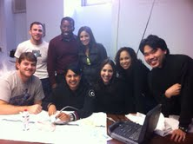
Participants enjoying the course posing for the camera

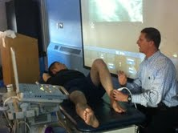
Dr. Lento demonstrating the foot and ankle ultrasound examination on a volunteer model

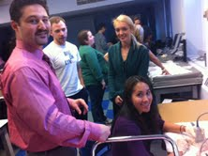
Dr. Kirschner observing Emerald Lin practice her ultrasound guided injection on a chicken leg

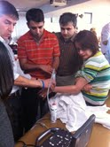
Dr. Malanga (far left) observing participants practicing the wrist examination during hands-on portion

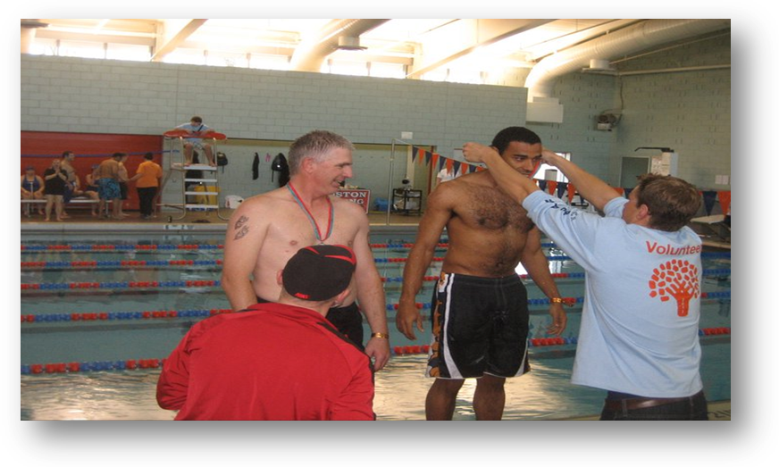

“Rehabilitation is to be a master word in medicine." These words were quite a bold statement when they were made by Dr. William Mayo, M.D., in 1925. However, in modern-day medicine, rehabilitation has indeed come to the forefront.
As the Physical Medicine and Rehabilitation Interest Group at Touro College of Osteopathic Medicine, our main objective is to create an awareness of this wonderful and growing specialty among our students. This is the inaugural year for the group, and thus far, it has been quite eventful. We kicked off the year as medical volunteers with the New York Special Olympics. During these events, students assisted PM&R residents from various programs throughout Manhattan in addressing athletic injuries, ranging from cuts and scrapes to ankle sprains to minor blunt force traumas. These events were inspiring and rewarding, and they evolved further with the addition of Physical Examination clinics that were geared toward that particular sport. These workshops were an excellent forum for students to refine their physical examination skills as well as an invaluable opportunity to garner some personal insight from residents about their experience in the specialty. We have cultivated great relationships with several of these residents who continue to serve as mentors and have also come to speak at an “Introduction to Physical Medicine and Rehabilitation” lecture at TouroCOM.
Other goals of the interest group include exposing students to specialties within PM&R and highlighting the roles of continuing education and research in the field. We have found the monthly lecture series hosted by the New York Society of Physical Medicine and Rehabilitation (NYSPMR) to be a fantastic venue for supplementing the education we receive in our pre-clinical years. We have been introduced to topics that students may have only a limited exposure to, such as “The Evolving Understanding of Mild Traumatic Brain Injury” (lecturer: Dr. Brian Greenwald, M.D.) and “Amputee Rehabilitation” (lecturer: Dr. Jeffrey Heckman, D.O.). This lecture series is a
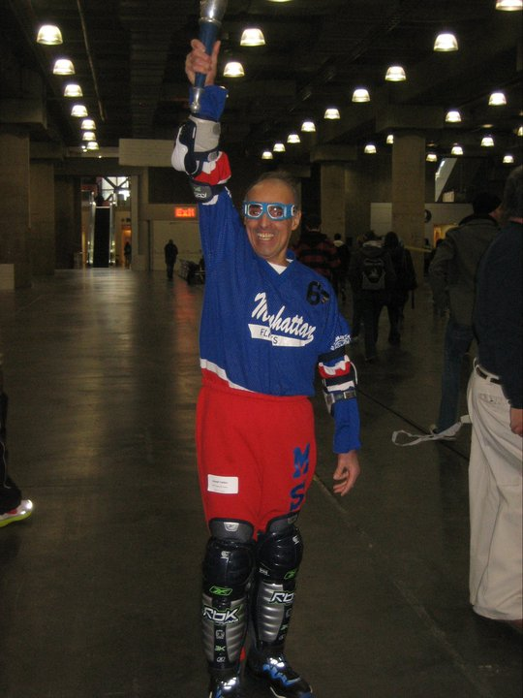
Special Olympic participant celebrates success
platform for students to gain a wider understanding of special topics within the field in addition to providing the opportunity to network with practicing physiatrists.
To encourage students to stay up-to-date with the research and literature within PM&R, we hold a monthly journal club meeting under the guidance of the Journal Club of the American Osteopathic College of Physical Medicine and Rehabilitation (AOCPMR). During these meetings, we have discussed various topics including “Adult Traumatic Brachial Plexus Injuries” and “The Minimally Conscious State”. The journal club facilitates the practice of presenting scientific papers in addition to providing the opportunity to converse about topics that we will address throughout our clinical careers. Furthermore, we provided information to the community on “Winter Safety and Fall Prevention” at the Harlem Health Fair this November. In the near future, we will be hosting an “Amputee Awareness” week that will include a viewing of Murderball (a documentary about Wheelchair Rugby) and a lecture on Amputee Rehabilitation. With all of these events and activities, we hope to develop the knowledge and insight that will enable us to someday be active and productive members of the field.
~ Kelly Joy Valignota Medical Student at TourCOM & NYSPMR Medical Student Liason Chair

ATTENDING’S CORNER

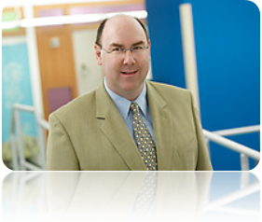
CANCER REHABILITATION

There is nothing more challenging, motivating, or inspirational than the opportunity to restore function and quality of life to cancer patients and survivors. When I accepted the physiatrist position at the Memorial Sloan-Kettering Cancer Center (MSKCC) in 2001, I honestly had no idea what I was in for. There was no guidance on what the service should look like, and I literally made it up as I went along. I naively went with what I knew – neuromuscular and musculoskeletal medicine. Fortunately, this was a recipe for success, as many of the issues faced by this population benefited greatly from this approach. I rapidly found my clinics full and my patients getting better. More than a decade later, I find myself Chief of the Rehabilitation Service at MSKCC. I work with two fantastic colleagues, and we have two stellar junior faculty joining us in July. Of course, we are still making it up as we go along! This is what inspired my career in cancer rehabilitation in the first place: the fact that this is very much the “wild west” of academic medicine. Almost everything we are doing is interesting, new, and exciting. One of my main interests is the neuromuscular and musculoskeletal sequelae of radiation therapy. I have seen hundreds of patients with complications of radiation and continue to see new complications on a regular basis. Many of these disorders either haven’t been described or are considered rare. It often makes you feel like one of the early pioneers of medicine. If a PM&R physician is to excel professionally they must love what they do. They have to be internally motivated to show up early, work hard while they are in the office, and stay late when needed. A successful physician would not see that as work, but as opportunity for discovery and to make a difference in the lives of their patients. They should be smart, focused, able to think out of the box, compassionate, and able to communicate these qualities clearly and concisely to their patients. Keep in mind that done properly, academic medicine is a 3-ring circus of deadlines, commitments, and stresses from multiple competing sources. I personally wouldn’t have it any other way. Success also means being able to balance an aggressive work life with an equally meaningfully home life. The best physician knows when their work is done so they can leave, turn off the blackberry (or iPhone), and have great quality time with their families, fabulous vacations, or something else outside of work that they value. They work hard so they can play hard. The ones who fail to negotiate a good work-life balance will burn out quickly. I try to balance my long hours at work by sharing long trips with my wife to the far ends of the globe, photographing and scuba diving. Passion outside of work is key to keeping your passion for work.
~Michael Stubblefield, MD Chief of Rehabilitation Services, Memorial Sloan-Kettering Cancer Center
ATTENDING’S CORNER

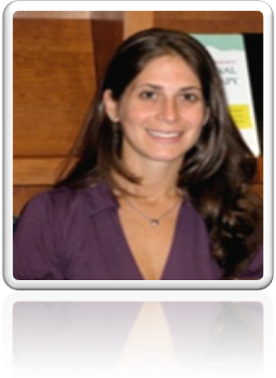
GERIATRIC REHABILITATION
Ever since high school, I knew I wanted to become a doctor. The marriage of the sciences, human body, continued learning, and the ability to help others is what I found most attractive of the health care field. Despite my early attractions, it wasn't until the end of my third year of medical school where I learned more about the field of Physical Medicine and Rehabilitation. I was immediately drawn to Physiatry, as I had finally found a specialty within medicine that was tailor made for my skill set and interests. In physical medicine and rehabilitation we have the unique opportunity to aid our patients in overcoming various disabilities in order to preserve function and quality of life. As physicians, we are given the enormous responsibility by our patients to give advice, support, and guidance within the often overwhelming experience of treating an ailment. It is the everyday dealings with patients that have motivated me to become a better clinician. We do our best to combine the subjective and objective findings to treat our patients in an evidence based, yet personally biased method of clinical treatment. It is the humanistic touch, the compassion and the quest for knowledge that makes an excellent physician.
During medical school and residency you may loose site that eventually there will come a time where you actually will get a job and get paid for doing what you love. Fortunately there are various settings where this can occur from academic medicine, hospital based setting and private practice. I wasn’t sure exactly where I wanted to practice, but I did know I wanted a job where I love going to work. Working in an academic, hospital based setting enables me to work with a team of health care professionals that share a similar passion and interest. As a junior faculty member, there is an abundant amount of support and mentorship both within my department as well as interdepartmental. There are opportunities for continued learning, faculty development and research. Furthermore, I am afforded the privilege to educate and interact with medical students and residents whose passion and enthusiasm for learning motivates me on a daily basis.
~Lyssa Sorkin, MD
Attending Physician New York Presbyterian- Columbia University Hospital

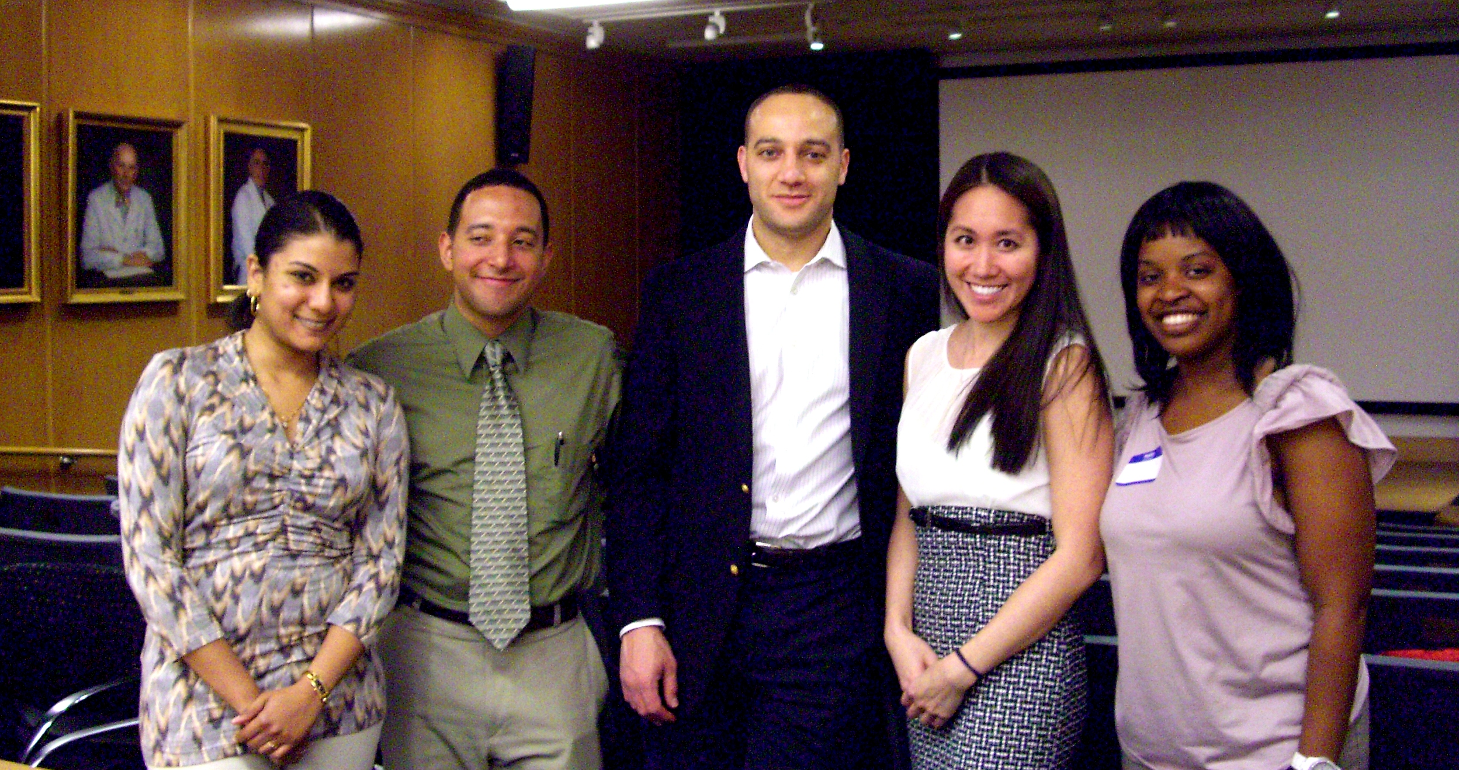
Ladies from left to right: President Sarah Khan, DO; Executive Board member, Emerald Lin, MD and Vice-President Mously Le Blanc, MD
Gentlemen: Dr. Miguel Corba, current Neurorehabilitation fellow at JFK with Dr. Neil Jasey, Fellowship Director of Traumatic Brain Injury at Kesseler. All attended the Career and Fellowship Fair
The Year in Review: Memorable Events

NYSPMR Career and Fellowship Fair
This year we held another successful Career and Fellowship Fair on April 2, 2012. We would like to thank you all for coming and participating in the NYSPMR Career and Fellowship Fair, especially to those who traveled in from NJ and PA. Fellowships included those offered by Hospital of Special Surgery, Kessler, Orthopedic and Spine Specialists, Mount Sinai, Montefiore, and Performance Spine & Sports Medicine. Other participants included Trelor and Heisel, PRI, and Linda Farr. Every year, participation increases and you
have helped make the Annual Career and Fellowship Fair a success. We have gotten great feedback from residents, fellows, attendings, our legal/financial planners and advertisers. We have begun the process of planning for next year, so please send us any feedback that you think would be helpful. And please send me the contact information of anyone who may be interested in participating.
~Emerald Lin, MD
Prosthetic and Orthotic Workshop
New York Society of Physical Medicine and Rehabilitation held a Lower Extremity Prosthetic and Orthotic Workshop on Saturday February 11, 2012 in the Mount Sinai Medical Center Conference Room. NYSPMR President, Sarah Khan coordinated the workshop from start to finish. The workshop was well received by a large number of residents from various New York physiatry residency programs. TMR Orthotics and Prosthetic Service Inc., provided all of the equipment models and numerous instructors for the course. Dr. Richard Frieden, an attending at Mount Sinai also served as a presenter during the course and discussed board review questions related to Prosthetics and Orthotics making this workshop extremely high yield. TMR Orthotic and Prosthetic Service started as a family run business and now has over 30 years of experience in providing patients with great quality prosthetics and orthotics and continue to serve as a knowledgeable source for resident education. Sarah Khan did an excellent job coordinating this workshop.
~Mously Le Blanc, MD
Resident Bowl
This year, we welcomed teams representing Montefiore, New York Medical Center, Mount Sinai, Long Island Jewish Medical Center, Kessler, and New York Presbyterian. It was a close and exciting match among all the teams, with a tiebreaker held between Montefiore’s and New York Medical Center’s programs. Montefiore was crowned this year's champions, narrowly winning by one question, with New York Medical Center earning a well-deserved second place. Afterwards, many participants and their supporters, including Program Directors and fellow residents attended a celebratory Social event at Sessions 73. Thank you to this year’s participants. We look forward to even more fierce competition next year.
~ Emerald Lin, MD
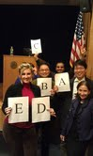
Winners from Montefiore celebrating their win with Department Chair, Michelle Stern, MD
Migraine Lecture and Dinner
In collaboration with Allergan, New York Society and Physical Medicine and Rehabilitation presented a Migraine Lecture over dinner at BLT Prime. A total of 25 residents representing various physiatry programs in New York City including SUNY Downstate, New York University, New York Medical College- Metropolitan, Montefiore and New York Presbyterian Hospitals- Cornell and Columbia to name a few. Dr. Paul-Henri Cesar, Director of Headache Medicine at Columbia University Neurology Department, delivered a dynamic lecture focusing on clinical diagnosis and management algorithms for migraines headaches utilizing multiple clinical vignettes. Prior to his lecture, Rita Singh, an Allergan representative from the Research Division educated the attendees about the mechanism of action of Botox, landmarks for Botox injection for Migraine headaches and the specifics of the PREEMPT trial which led to the FDA approval of Botox for the indication of Migraines. BLT Prime accommodated our group in a large private room with a large display TV for the PowerPoint presentations. Dinner included a choice of 3 gourmet salads, 2 bread options, 3 desserts and a choice of steak, chicken or tuna making for a rather enjoyable and appetizing dinner.
~Mously Le Blanc, MD

SPECIAL OLYMPICS EVENTS

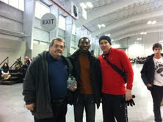
NYSPMR Board Member Isaac Darko, MD posing with organizers of a Special Olympic event
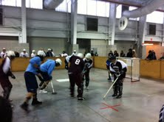
Special Olympic field hockey competition

